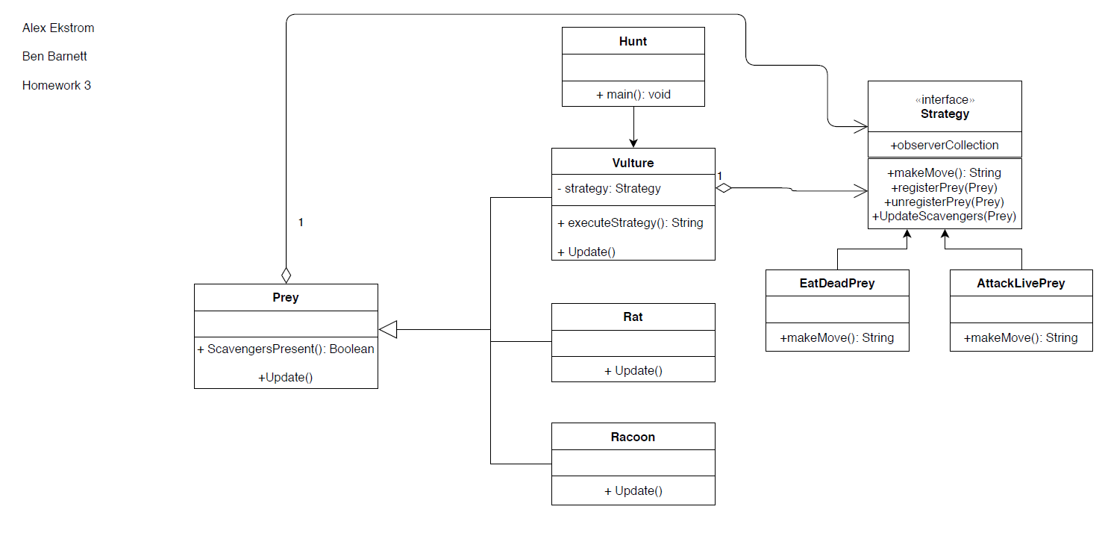Exercise 1

Observer POV

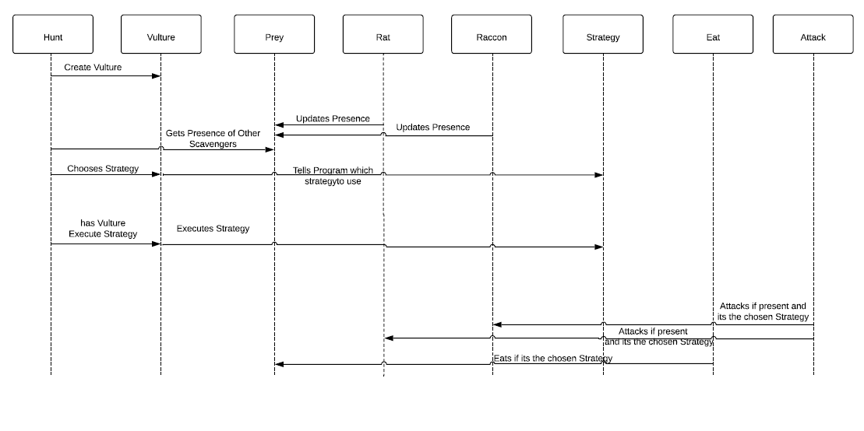

Strategy POV

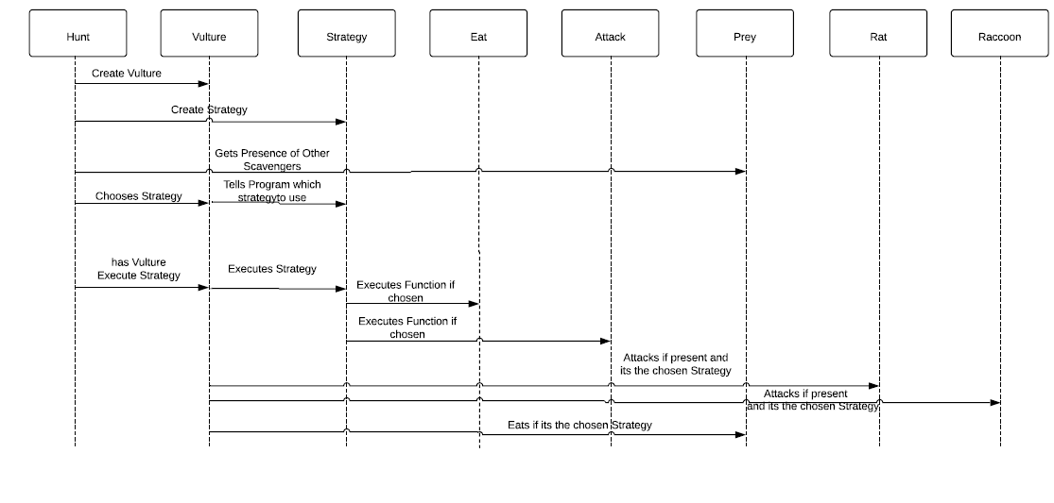

Exercise 2

A. The teams estimated velocity for the next sprint is 51

B. In order to estimate a focus factor for a brand new team, it is recommended to plan the initial velocity at one-third of available time for the team.

C. Another strategy that can be used to estimate story points is to assign the tasks based on priority number, for example if a task has a 2 then it will require twice as much work as the task labeled 1. The poker method is still a better way to estimate because before a task is given points, every person must agree on how many points it should receive.

D.

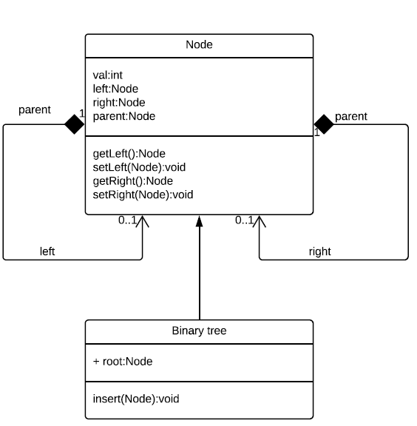

E. public class Node

{

Int val;

Node left;

Node right;

Node parent;

Node(int val, Node parent)

{

this.val = val;

right = null;

left = null;

}

//sets right node

public void setR(Node r)

{

right = r;

}

//sets left node

public void setL(Node l)

{

left = l;

}

//return right node

public Node getR()

{

return right;

}

//return left node

public Node getL()

{

return left;

}

public Node getParent()

{

return parent;

}

}

public class BinaryTree

{

Node root;

public void insert(Node n)

{

“insert algorithm here”

}

}

F.

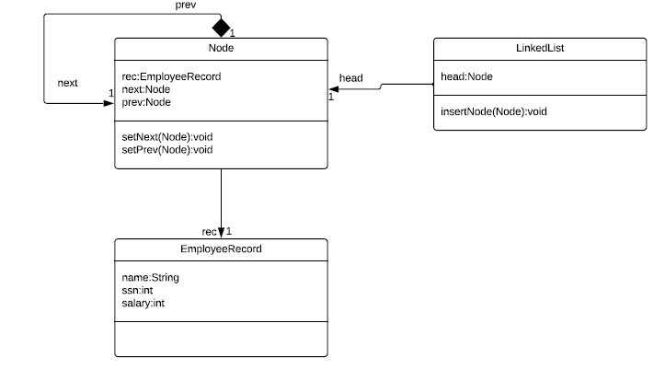

G.

public class Node

{

Node next;

Node prev;

EmployeeRecord rec;

Node(EmployeeRecord rec)

{

this.rec = rec;

}

public void setNext(Node n)

{

next = n;

}

public void setPrev(Node p)

{

prev = p;

}

}

public class EmployeeRecord

{

String name;

Int ssn;

Int salary;

}

public class LinkedList

{

Node head;

public void insertNode(Node n)

{

“insert algorithm here”

}

}